CSCI 5380

Network Virtualization and Orchestration

Lab 3

OpenStack: Service-Chaining

University of Colorado Boulder

Department of Computer Science

Network Engineering

Professor Levi Perigo, Ph.D.

# **PART 1: Service chaining**

# Summary:

In this part, you will manage service chaining in OpenStack.

# Section 1: In-network service chaining:

Create the service chaining in Figure 2 according to the lecture instructions.

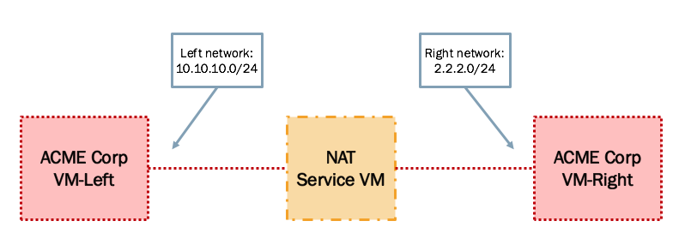

Figure 2. In-Network Service Chaining setup

You can either create your own NAT VM appliance or download and use one from another source such as: [pfSense](https://github.com/OverFlowJAMK/General/wiki/Installing-PFSense-into-OpenStack).

# Deliverable (100 points):

Create a tutorial document indicating the steps to achieve this lab.